**EXPERIMENT-13**

**Submitted by:**Ajay Kumar Tyagi  
500067403  
R171218008  
CSE-DevOps

**Aim:** To prepare and implement docker container restart policy.

**Procedure:**

**1)** Docker considers any containers to exit with a non-zero exit code to have crashed. By default a crashed container will remain stopped. Use command  
**docker run -d --name restart-default scrapbook/docker-restart-example.** You will see container has crashed.  
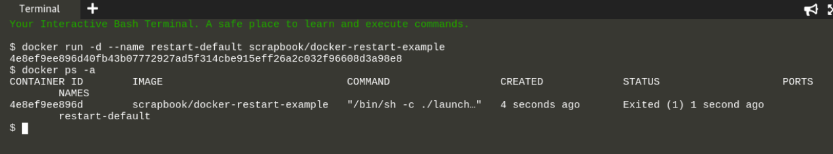

**2)** We can also see logs of this crashed container using command docker logs <container-name>.  
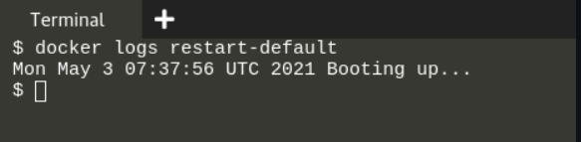

**3)** The option **--restart=on-failure** allows you to say how many times Docker should try again. In the example below, Docker will restart the container three times before stopping.  
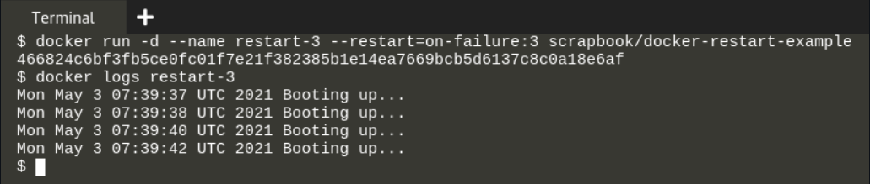

**4)** Use the **always flag** to automatically restart the container when is crashes for example.  
